SIMATS ENGINEERING
DEPARTMENT OF COMPUTER SCIENCE AND ENGINEERING
DESIGN AND ANALYSIS OF ALGORITHMS
CO1 ASSESSMENT TOOL – 1 REPORT
QUESTION 41
APPLICATION: PARALLEL TASK SCHEDULING SYSTEM
Student Name: Adhiti . S
Register Number: 192411069
Faculty Name: Dr Rajagopal K
Course Code: CSA0606
Course Name: Design and Analysis of Algorithms
Date of Submission: 20-07-2026

ABSTRACT
The efficient scheduling of computational tasks is essential for improving the performance of modern distributed computing systems. Applications such as cloud computing, parallel processing, and data centres execute a large number of tasks simultaneously, making efficient task scheduling a critical requirement. Many scheduling algorithms employ the Divide and Conquer technique, where a large scheduling problem is recursively divided into smaller subproblems before combining the results. The execution time of such recursive algorithms is represented using recurrence relations, which can be analysed using the Master Theorem.
This report presents the analysis of the recurrence relation T(n) = 7T(n/2) + n, which models task scheduling in a Parallel Task Scheduling System. The Master Theorem is applied to identify the recurrence parameters, determine the applicable case, and derive the asymptotic time complexity. The analysis shows that the given recurrence satisfies Case 1 of the Master Theorem, resulting in a time complexity of Θ(n<sup>log₂7</sup>), which is approximately Θ(n²·⁸⁰⁷). This complexity indicates that the algorithm performs a large amount of recursive computation as the number of tasks increases.
In addition to the theoretical analysis, the report discusses the practical role of divide-and-conquer algorithms in distributed task scheduling, presents the implementation through a C program, and evaluates the algorithm using asymptotic notations such as Big-O, Big-Theta, and Big-Omega. The findings highlight how recurrence analysis assists software engineers in understanding algorithm performance and selecting suitable scheduling techniques for large-scale distributed computing environments.
Keywords: Parallel Task Scheduling System, Divide and Conquer, Master Theorem, Recurrence Relation, Time Complexity, Distributed Computing, Algorithm Analysis, Asymptotic Analysis.

- INTRODUCTION
The rapid growth of cloud computing, distributed systems, and high-performance computing has significantly increased the demand for efficient task scheduling algorithms. Modern computing environments execute thousands of computational tasks simultaneously across multiple processors, servers, and distributed nodes. Efficient scheduling is essential for maximizing processor utilization, minimizing execution time, balancing workloads, and improving overall system performance. Applications such as cloud services, scientific simulations, artificial intelligence, big data analytics, and parallel processing rely heavily on optimized scheduling techniques to execute large numbers of tasks efficiently.
One of the most widely used algorithm design paradigms for solving large computational problems is the Divide and Conquer technique. Instead of processing an entire workload as a single unit, divide-and-conquer algorithms recursively partition the problem into smaller subproblems that can be solved independently. Once each subproblem has been processed, the individual results are combined to obtain the final solution. This strategy not only simplifies complex problems but also enables parallel execution, making it highly suitable for distributed computing environments.
Since divide-and-conquer algorithms rely on recursion, their execution time is represented using recurrence relations. A recurrence relation expresses the running time of a problem in terms of the running time of smaller instances of the same problem. As the input size increases, manually expanding recurrence relations becomes increasingly difficult. Therefore, algorithm designers use the Master Theorem, a mathematical technique that directly determines the asymptotic time complexity of a large class of divide-and-conquer recurrences.
The parameters of the recurrence are identified, the applicable case of the Master Theorem is justified, and the resulting asymptotic complexity is determined. Furthermore, the report discusses how the obtained complexity affects the scalability and efficiency of distributed computing systems as the number of computational tasks increases.

- AIM
The primary aim of this study is to analyse the recurrence relation T(n) = 7T(n/2) + n using the Master Theorem and determine its asymptotic time complexity in the context of a Parallel Task Scheduling System. The study also aims to understand how divide-and-conquer algorithms influence task scheduling efficiency, evaluate their performance as the number of computational tasks increases, and interpret the algorithm's behaviour using standard asymptotic notations such as Big-O (O), Big-Theta (Θ), and Big-Omega (Ω).
- OBJECTIVES
- To understand the concept of divide-and-conquer algorithms and their role in distributed computing systems.
- To study the recurrence relation associated with a Parallel Task Scheduling System.
- To identify the Master Theorem parameters (a, b, and f(n)).
- To determine the appropriate case of the Master Theorem for the given recurrence relation.
- To calculate the asymptotic time complexity of the scheduling algorithm.
- To analyse the system performance as the number of computational tasks increases.
- To implement a simple C program that demonstrates the recurrence analysis.
- To interpret the algorithm's efficiency using asymptotic notations and discuss its practical significance in parallel and distributed computing environments.

- PROBLEM STATEMENT
A Parallel Task Scheduling System distributes computational tasks among multiple processors to improve execution efficiency and reduce overall processing time. To schedule tasks recursively, the system follows the recurrence relation 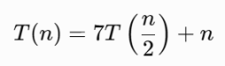
where:
- 7T(n/2) represents seven recursive scheduling operations, each handling half of the original task set.
- n represents the additional linear work required for task allocation, coordination, and scheduling overhead.
5. BACKGROUND THEORY
5.1 ALGORITHM ANALYSIS
Algorithm analysis is the process of evaluating the efficiency of an algorithm in terms of the time and memory required for execution. Rather than measuring performance on a specific computer system, algorithm analysis focuses on how computational resources grow as the size of the input increases. This approach enables software developers to compare different algorithms and select the most efficient solution for a particular application.
The performance of an algorithm is commonly expressed using asymptotic notations, which describe the growth rate of execution time independent of hardware specifications or programming language. In distributed computing systems, algorithm analysis plays a vital role in predicting execution time, processor utilization, and system scalability when handling large numbers of computational tasks.
5.2 DIVIDE AND CONQUER TECHNIQUE
Divide and Conquer is one of the most effective algorithm design strategies used in computer science. The fundamental idea is to divide a complex problem into several smaller subproblems of the same type, solve each subproblem recursively, and combine their solutions to obtain the final result.
The divide-and-conquer strategy consists of three phases:
Divide
The original scheduling problem is divided into multiple smaller and independent subproblems that can be processed separately.
Conquer
Each subproblem is solved recursively. When the size of a subproblem becomes sufficiently small, it is solved directly without further division.

Combine
The results obtained from all subproblems are combined to produce the final task schedule.
This strategy improves computational efficiency and is widely used in algorithms such as Merge Sort, Quick Sort, Binary Search, Strassen's Matrix Multiplication, and parallel task scheduling algorithms used in distributed computing environments.
5.3 RECURRENCE RELATIONS
A recurrence relation is a mathematical equation that expresses the execution time of a recursive algorithm in terms of the execution time required for smaller input sizes. It provides a systematic approach for analysing recursive algorithms without executing them.
A general recurrence relation is represented as
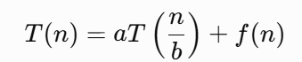
where
- T(n) represents the total execution time for an input of size n.
- a denotes the number of recursive calls.
- b represents the factor by which the input size is reduced during each recursive call.
- f(n) represents the work performed outside the recursive calls, such as task allocation, synchronization, communication, or scheduling.
Recurrence relations are widely used to analyse divide-and-conquer algorithms because they describe how the running time changes as the problem size decreases recursively.
5.4 IMPORTANCE OF THE MASTER THEOREM
Expanding recurrence relations repeatedly to determine their running time becomes increasingly difficult for large input sizes. The Master Theorem provides a direct and systematic technique for solving a wide class of divide-and-conquer recurrence relations without performing lengthy recursive expansions.
The theorem compares the amount of work performed by the recursive calls with the work performed outside the recursion. Based on this comparison, it identifies the dominant factor influencing the algorithm's running time and determines the corresponding asymptotic complexity.
In parallel task scheduling systems, the Master Theorem helps software engineers evaluate whether a scheduling algorithm can efficiently handle increasing workloads. By predicting the computational complexity, developers can estimate execution time, resource utilization, and scalability before implementing the algorithm in real-world distributed systems.

6. APPLICATION OVERVIEW
6.1 PARALLEL TASK SCHEDULING SYSTEM
A Parallel Task Scheduling System is responsible for distributing computational tasks among multiple processors or computing nodes so that they can execute simultaneously. Such systems are widely used in cloud computing, distributed databases, scientific simulations, artificial intelligence, and high-performance computing, where thousands of tasks must be completed within a limited time.
Instead of assigning all tasks to a single processor, the scheduler divides the workload into smaller independent task groups. Each group is assigned to a different processor, allowing multiple tasks to execute concurrently. After all processors complete their assigned tasks, the scheduler combines the results to produce the final output.
This divide-and-conquer strategy improves processor utilization, reduces execution time, and enables efficient handling of large computational workloads.
6.2 WORKING PRINCIPLE
The operation of a Parallel Task Scheduling System follows a systematic workflow:
- The scheduler receives a large collection of computational tasks.
- The tasks are divided into smaller groups.
- Each group is assigned to different processors or computing nodes.
- All processors execute their assigned tasks simultaneously.
- The scheduler collects and combines the completed results.
- The final output is delivered to the application.

- SYSTEM WORKFLOW
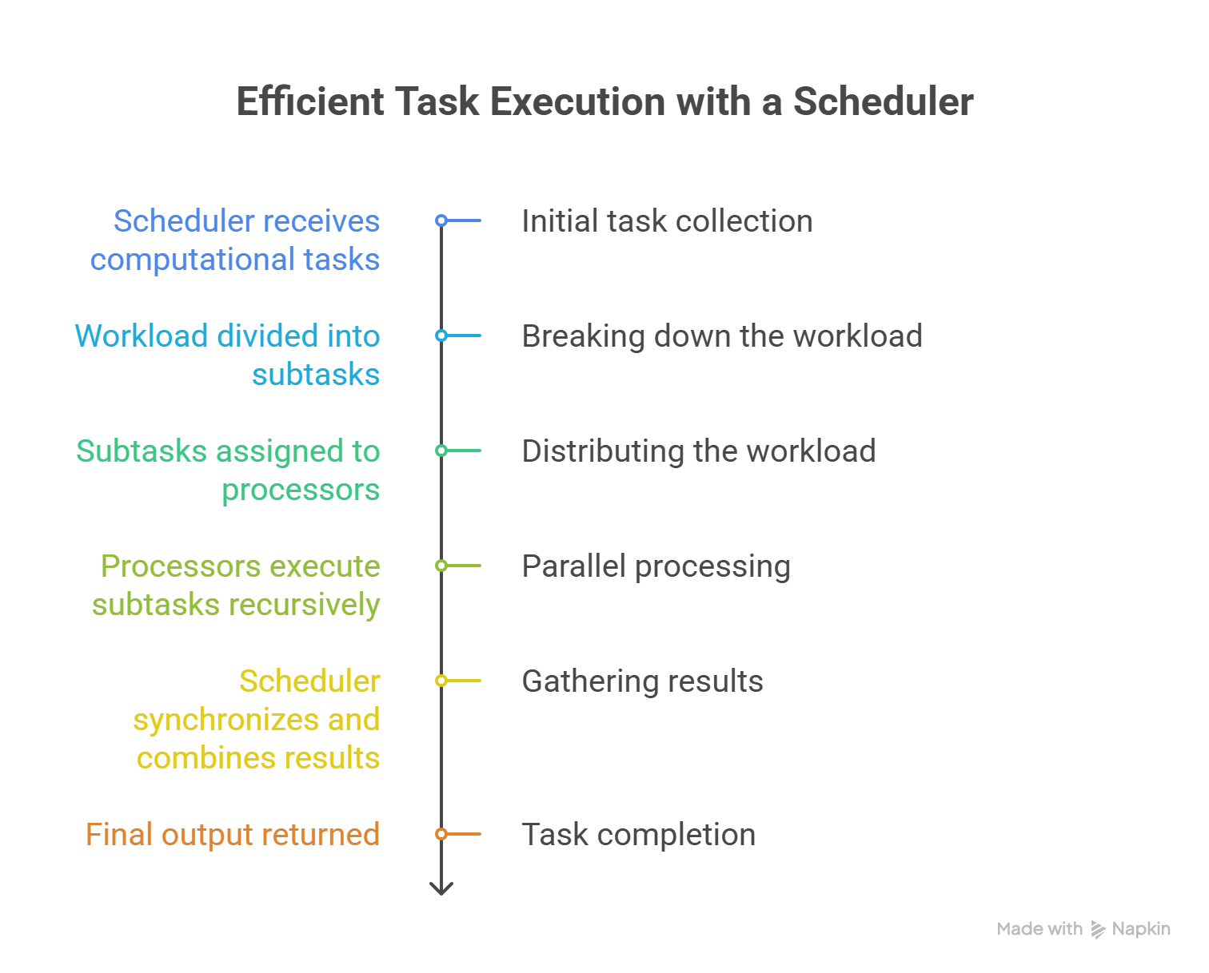

- MASTER THEOREM IMPLEMENTATION AND ANALYSIS
  - GENERAL FORM OF THE MASTER THEOREM
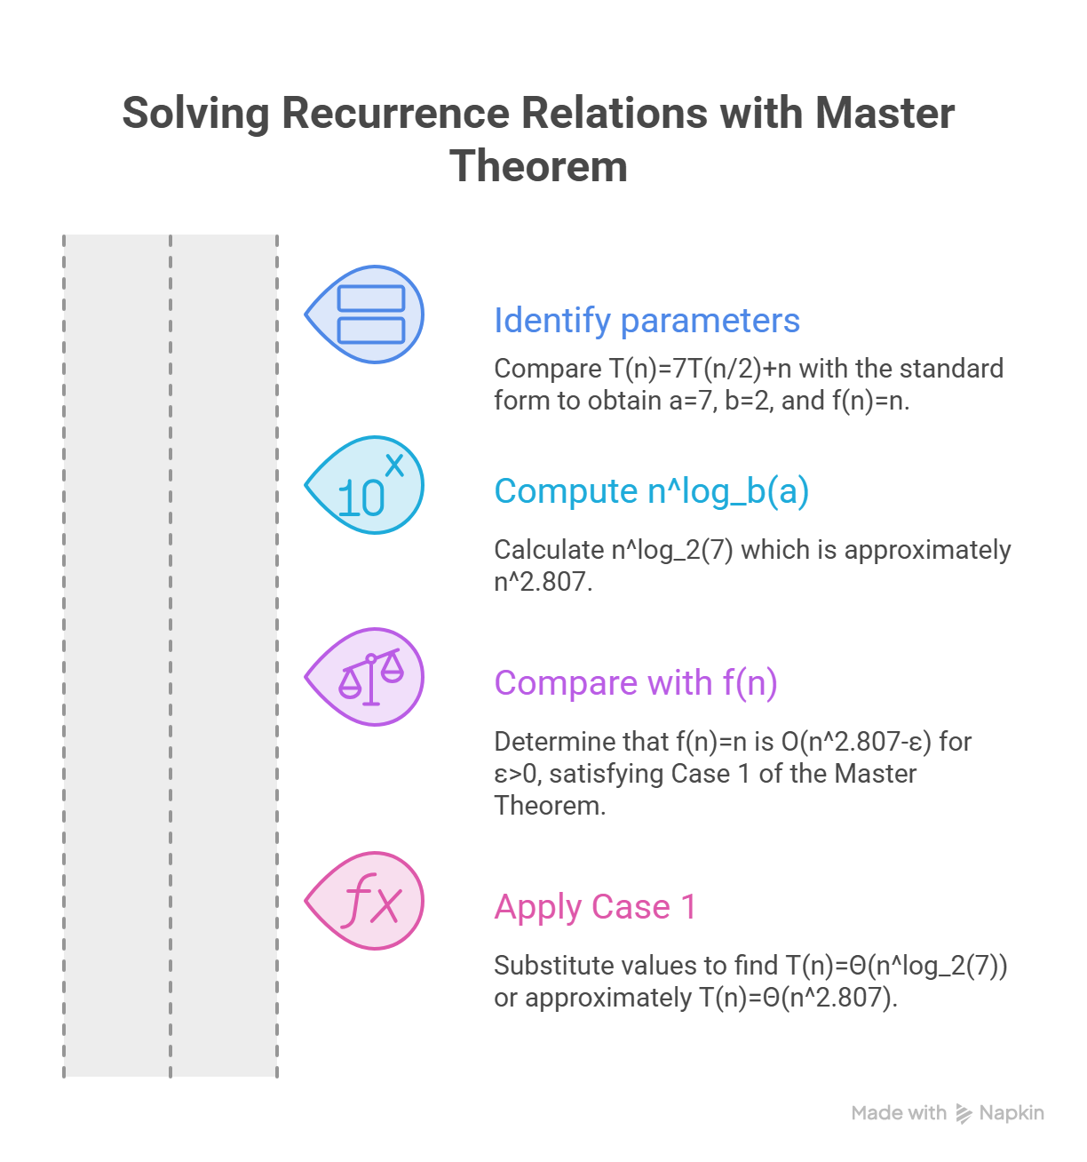

  - FINAL RESULTS
Parameter | Result
Recurrence Relation | (T(n)=7T(n/2)+n)
a | 7
b | 2
(f(n)) | n
(n^{\log_ba}) | (n^{2.807})
Master Theorem Case | Case 1
Time Complexity | Θ(n²·⁸⁰⁷)

  - INTERPRETATION
The obtained complexity indicates that the recursive computation dominates the execution time of the scheduling algorithm. At every recursive level, seven new scheduling operations are created while the input size is reduced by half. Although the divide-and-conquer approach allows multiple subtasks to execute in parallel, the large number of recursive calls causes the overall computational cost to grow rapidly.
As the number of computational tasks increases, the execution time increases approximately in proportion to n2.807n^{2.807}n2.807. Consequently, this algorithm is less scalable than algorithms with Θ(n log n) complexity, but it remains an important example for understanding how highly recursive divide-and-conquer algorithms are analysed using the Master Theorem.

9. IMPLEMENTATION
9.1 Implementation Overview
The program implements the recurrence relation for the Parallel Task Scheduling System and applies the Master Theorem to determine its asymptotic time complexity. The implementation is intended for educational purposes and does not perform actual parallel task scheduling. Instead, it illustrates how the recurrence relation is analysed by identifying the values of a, b, and f(n) and displaying the corresponding Master Theorem case and time complexity.
9.2 Development Environment
Component | Specification
Programming Language | C
Compiler | Online C Compiler
IDE | Code::Blocks / Visual Studio Code
Operating System | Windows 10/11
Processor | Intel Core i5 or above
RAM | 4 GB or higher
9.3 Implementation Steps
The implementation follows these steps:
- Read the input size n from the user.
- Display the recurrence relation T(n) = 7T(n/2) + n.
- Identify the Master Theorem parameters:
  - a = 7
  - b = 2
  - f(n) = n
- Compute n^(log₂7) using the Master Theorem.
- Determine the applicable theorem case (Case 1).
- Display the asymptotic time complexity Θ(n^log₂7) (approximately Θ(n²·⁸⁰⁷)).
- End the program.

10. SOURCE CODE
#include <stdio.h>

int main() {
int n;

printf("Parallel Task Scheduling System\n");
printf("---------------------------------\n");

printf("Enter the number of tasks: ");
scanf("%d", &n);

printf("\nRecurrence Relation: T(n) = 7T(n/2) + n\n");

printf("\nMaster Theorem Parameters:\n");
printf("a = 7\n");
printf("b = 2\n");
printf("f(n) = n\n");

printf("\nSince n < n^(log2 7),\n");
printf("The recurrence satisfies Case 1 of the Master Theorem.\n");

printf("\nTime Complexity = Theta(n^(log2 7))\n");
printf("Approximately = Theta(n^2.807)\n");

return 0;
}
11. PROGRAM OUTPUT
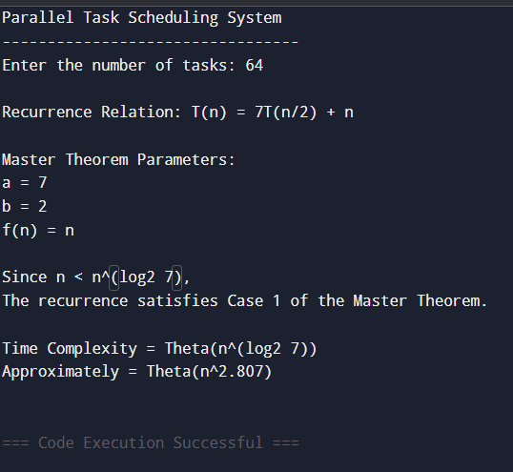

12. COMPLEXITY ANALYSIS
The recurrence relation representing the Parallel Task Scheduling System is 
Applying the Master Theorem,
- a=7a = 7a=7
- b=2b = 2b=2
- f(n)=nf(n) = nf(n)=n
Since
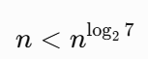
the recurrence satisfies Case 1 of the Master Theorem.
Therefore, 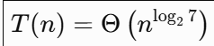 or approximately,
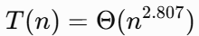
The complexity indicates that the recursive work dominates the execution time. At every level of recursion, the algorithm creates seven smaller scheduling problems while reducing the task size by half. Although the divide-and-conquer strategy enables parallel execution, the large number of recursive calls causes the running time to increase rapidly as the number of tasks grows.
Notation | Complexity
Best Case | Θ(n2.807)
Average Case | Θ(n2.807)
Worst Case | Θ(n2.807)
Big-O | O(n2.807)
Big-Theta | Θ(n2.807)
Big-Omega | Ω(n2.807)

13. SCALABILITY ANALYSIS
Scalability refers to the ability of a system or algorithm to maintain acceptable performance as the size of the input increases. In a Parallel Task Scheduling System, scalability is particularly important because distributed computing environments often execute thousands or even millions of computational tasks simultaneously.
The recurrence relation shows that every scheduling operation generates seven recursive subproblems, each of half the original size. Although these subtasks can be executed concurrently on multiple processors, the total number of recursive calls grows rapidly, increasing the computational overhead.
As the workload increases:
- More recursive scheduling operations are created.
- Additional synchronization and coordination are required.
- Processor utilization improves due to parallel execution.
- Overall execution time increases because of the high recursive complexity.
Consequently, the algorithm provides efficient workload distribution but is less scalable than divide-and-conquer algorithms with lower asymptotic complexity. In practical distributed systems, scheduling algorithms with lower time complexity are generally preferred for handling extremely large workloads.
14. ADVANTAGES
The Parallel Task Scheduling System offers several advantages:
- Efficiently distributes computational tasks among multiple processors.
- Supports parallel execution, reducing idle processor time.
- Improves resource utilization in distributed computing environments.
- Provides a structured approach for solving large scheduling problems using divide-and-conquer.
- The Master Theorem enables quick and systematic analysis of the algorithm's time complexity.
15. LIMITATIONS
Despite its advantages, the algorithm has certain limitations:
- Generates a large number of recursive calls, increasing computational overhead.
- Time complexity Θ(n²·⁸⁰⁷) grows rapidly for very large inputs.
- Requires additional synchronization between processors during task execution.
- Less efficient than scheduling algorithms with Θ(n log n) complexity.
- High recursion depth may increase memory consumption and stack usage in practical implementations.
16. CONCLUSION
This report presented the analysis of the recurrence relation T(n) = 7T(n/2) + n for a Parallel Task Scheduling System using the Master Theorem. By identifying the recurrence parameters and applying Case 1 of the theorem, the asymptotic time complexity was determined as Θ(n<sup>log₂7</sup>), which is approximately Θ(n²·⁸⁰⁷).
The analysis demonstrates that although the divide-and-conquer strategy enables parallel execution and efficient task distribution, the large number of recursive calls results in significant computational growth as the input size increases. Consequently, the algorithm is less scalable than algorithms with lower asymptotic complexity but remains valuable for understanding the behaviour of recursive scheduling algorithms.
The implementation of the C program further illustrates the theoretical concepts discussed in the report and highlights the importance of recurrence analysis in evaluating algorithm performance. Overall, this study demonstrates how the Master Theorem serves as an effective tool for analysing divide-and-conquer algorithms used in modern distributed computing and parallel processing systems.

17. REFERENCES
- Cormen, T. H., Leiserson, C. E., Rivest, R. L., & Stein, C. Introduction to Algorithms (4th Edition). MIT Press, 2022.
- Horowitz, E., Sahni, S., & Rajasekaran, S. Fundamentals of Computer Algorithms (2nd Edition). Universities Press, 2008.
- Kleinberg, J., & Tardos, É. Algorithm Design. Pearson Education, 2006.
- Sedgewick, R., & Wayne, K. Algorithms (4th Edition). Addison-Wesley Professional, 2011.
- Goodrich, M. T., Tamassia, R., & Goldwasser, M. H. Data Structures and Algorithms in Java (6th Edition). Wiley, 2014.

